Levon Dahjet | levon.dahjet@gmail.com | 5/5/2019 | threeDayAverage
 Report Parameters
Day 1
:
Day 2
:
Day 3
:
05
/
03
/
2019
05
/
05
/
2019
05
/
05
/
2019
 3-Day Average

Intake vs. Goals
5/3/2019, 5/5/2019, 5/5/2019
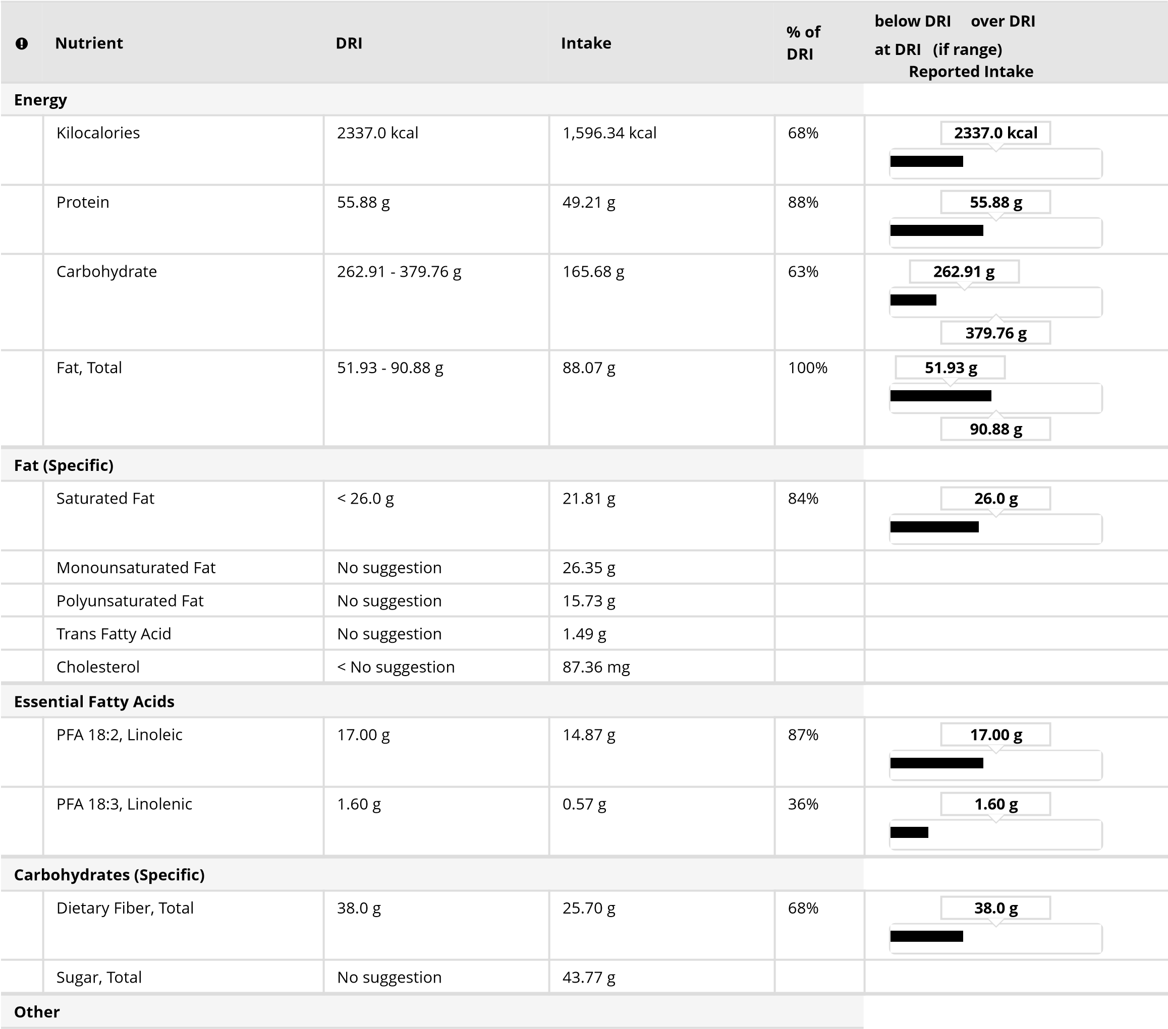
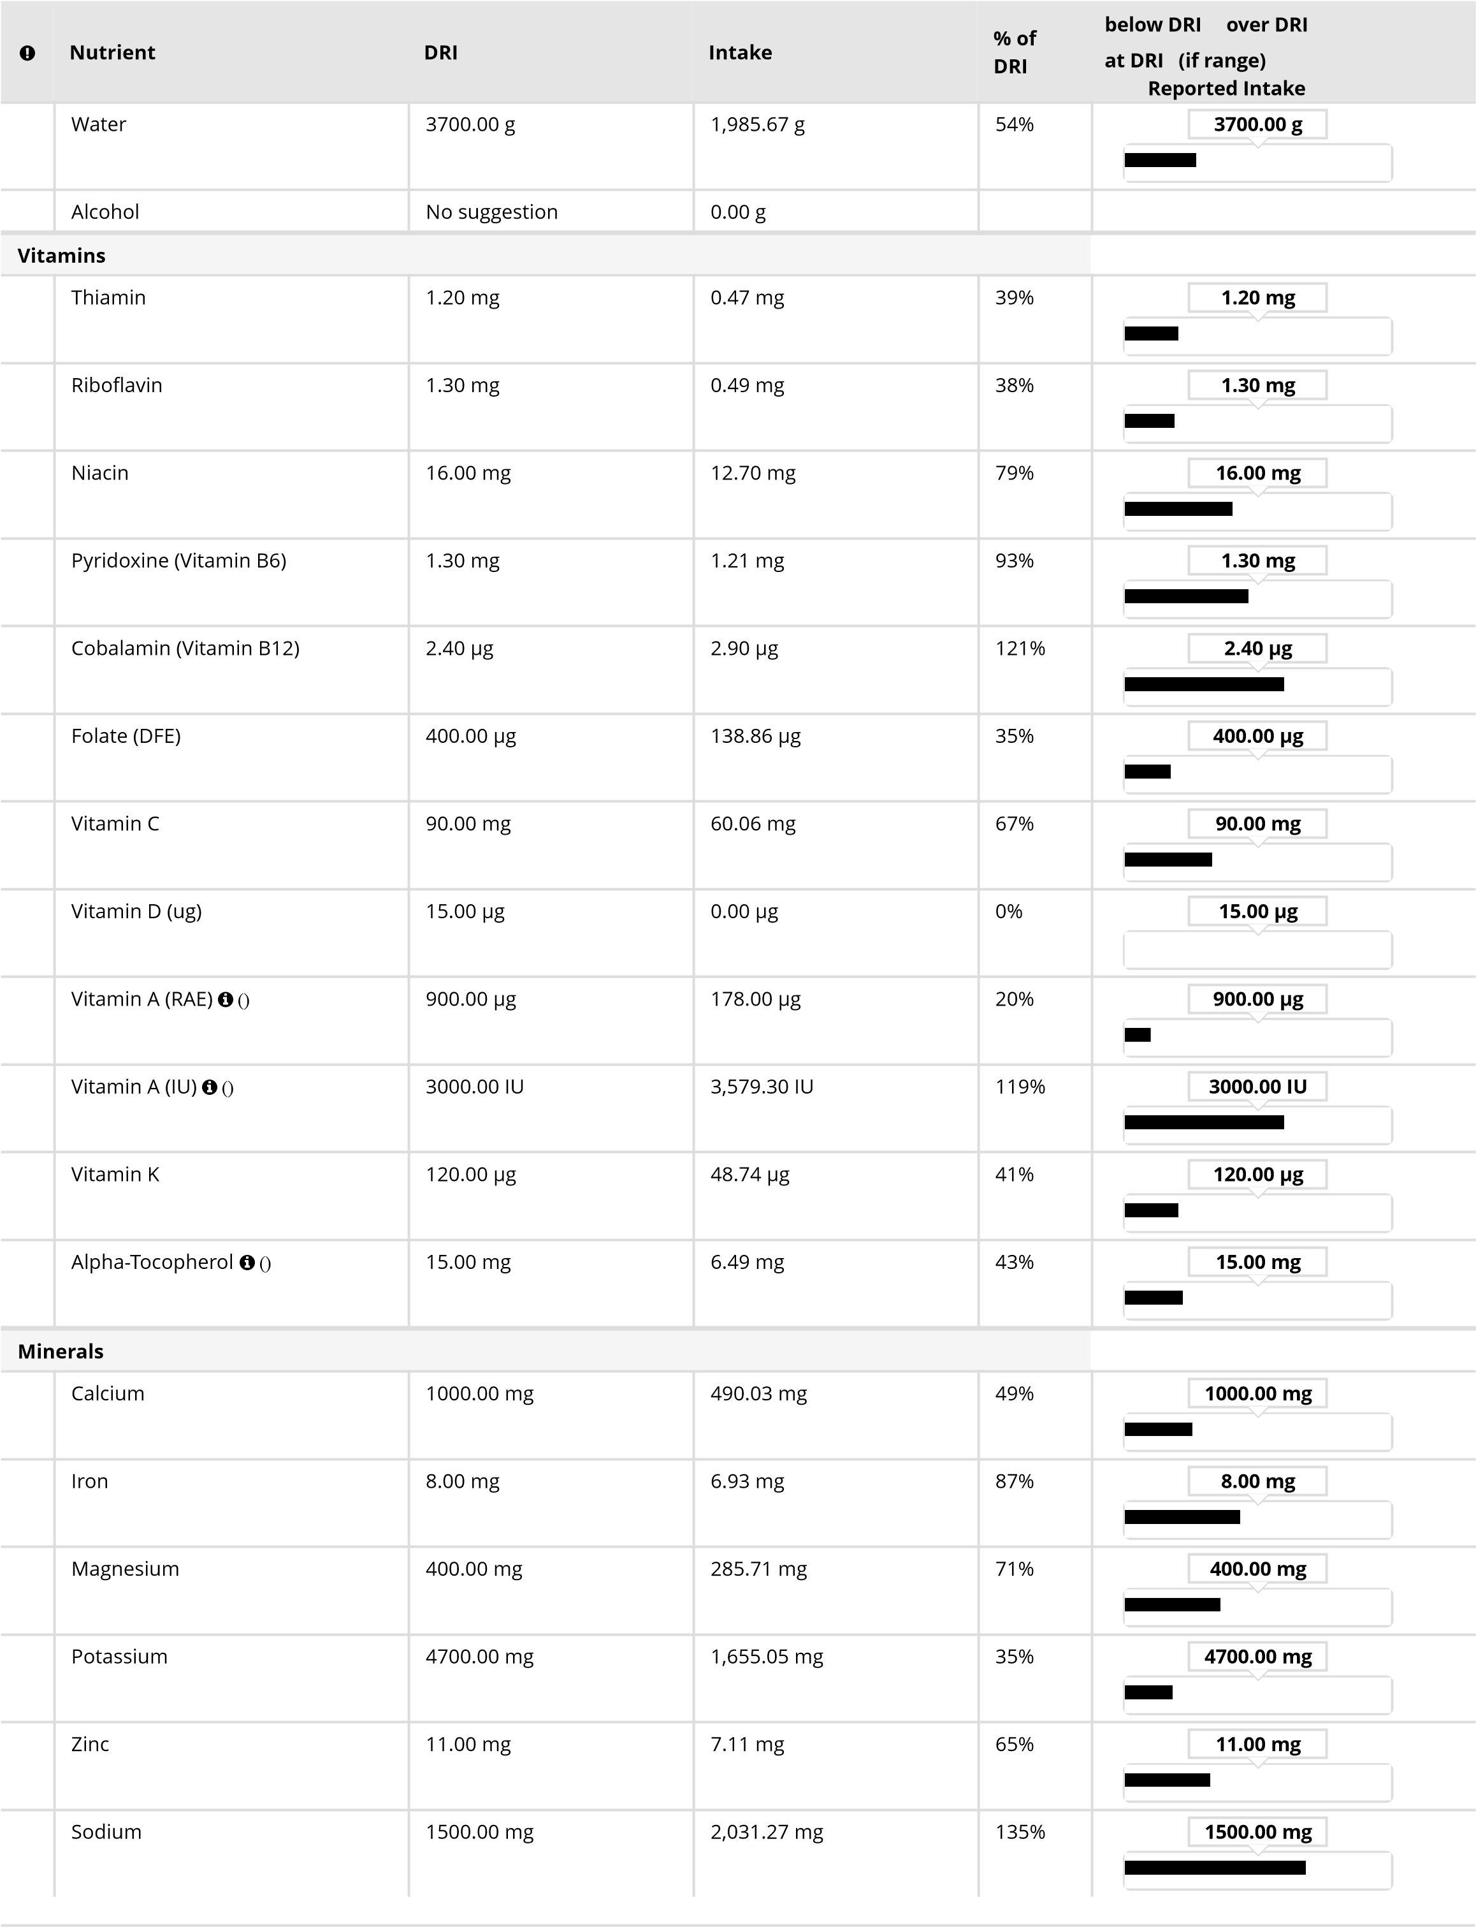
DRI Report
Profile
Active Profile: | Primary Profile
Height: | 5 ft. 11 inches
Weight: | 154 lbs.
Age: | 20 years
BMI: | 21.5
Gender: | Male
Pregnancy: | Not Pregnant
Activity Level: | Sedentary
Smoker: | no
Strict Vegetarian/Vegan: | no
Nutrient | DRI
Energy
Kilocalories | 2337.0 kcal
Protein | 55.88 g AMDR: 10%-35% of kilocalories  RDA: Daily requirement based on 0.8 grams of protein per kilogram body weight
Carbohydrate | 262.91 - 379.76 g AMDR: 45%-65% of kilocalories  RDA: 130 g/day for adults and children
Fat, Total | 51.93 - 90.88 g AMDR: 20%-35% of kilocalories
Fat (Specific)
Saturated Fat | < 26.0 g Less than 10% of kilocalories
Monounsaturated Fat | * No recommendation
Polyunsaturated Fat | * No recommendation
Trans Fatty Acid | * No recommendation
Cholesterol | < * Less than mg recommended
Essential Fatty Acids
PFA 18:2, Linoleic | 17.00 g
PFA 18:3, Linolenic | 1.60 g
Carbohydrates (Specific)
Dietary Fiber, Total | 38.0 g
Sugar, Total | * No recommendation
Other
Water | 3700.00 g
Alcohol | * No recommendation
Vitamins
Thiamin | 1.20 mg
Riboflavin | 1.30 mg
Niacin | 16.00 mg
Pyridoxine (Vitamin B6) | 1.30 mg
Cobalamin (Vitamin B12) | 2.40 µg
Folate (DFE) | 400.00 µg
Vitamin C | 90.00 mg
Vitamin D (ug) | 15.00 µg
Vitamin A (RAE)  () | 900.00 µg
Nutrient | DRI
Vitamin A (IU)  () | 3000.00 IU
Vitamin K | 120.00 µg
Alpha-Tocopherol  () | 15.00 mg
Minerals
Calcium | 1000.00 mg
Iron | 8.00 mg
Magnesium | 400.00 mg
Potassium | 4700.00 mg DRI Adequate Intake
Zinc | 11.00 mg
Sodium | 1500.00 mg DRI Adequate Intake

 | Recommended |  | Actual Intake
Total Calories | 2337 kcal |  | 1,596 kcal
Carbs | 1,052-1,519 kcal | 45%-65% | 663 kcal | 42%
Protein | 234-818 kcal | 10%-35% | 197 kcal | 12%
Fats | 467-818 kcal | 20%-35% | 793 kcal | 50%
Alcohol | 0 kcal | 0% | 0 kcal | 0%




Fat Breakdown
%
0
|
%
25
|
%
50
|
%
75
|
100
%
|
Source of Fat
Monounsaturated Fat
15
%
Polyunsaturated Fat
9
%
Saturated Fat
12
%
* Transfat data is not yet reported by all sources and therefore may be under-represented.
Macronutrient Ranges
/3/2019, 5/5/2019, 5/
5
5/2019
Carbs
Protein
Fat
Alcohol
0.0
200
400
600
800
1.0
k
k
1.2
k
1.4
Calories
Actual
Recommended
5/3/2019, 5/5/2019, 5/5/2019

0
%
|
25
%
|
50
%
|
75
%
|
100
%
|
Source of Fat
Trans Fatty Acid
1
%
Unspecified
13
%
* Transfat data is not yet reported by all sources and therefore may be under-represented.
MyPlate Analysis
5/3/2019, 5/5/2019, 5/5/2019
 | Goal * Actual % Goal
Grains (unsafe:javascript:  void(0);) | 8.0 oz. eq. | tips (unsafe:javascript:  void(0);) | 4.3 oz. eq. | 53.1 %
Vegetables  (unsafe:javascript:  void(0);) | 3.0 cup eq. | tips (unsafe:javascript:  void(0);) | 1.3 cup eq. | 41.7 %
Fruits (unsafe:javascript:  void(0);) | 2.0 cup eq. | tips (unsafe:javascript:  void(0);) | 2.6 cup eq. | 127.5 %
Dairy (unsafe:javascript:  void(0);) | 3.0 cup eq. | tips (unsafe:javascript:  void(0);) | 2.0 cup eq. | 66.7 %
Protein Foods (unsafe:javascript:  void(0);) | 6.5 oz. eq. | tips (unsafe:javascript:  void(0);) | 5.3 oz. eq. | 80.8 %
Empty Calories | 330.0 kcal |  | 408.0 kcal | 123.6 %
(unsafe:javascript: void(0);)

Intake Spreadsheet
5/3/2019
Item Name Meal |  | Quantity | Wt (g) | Kcal
Total |  |  | 2,377.70 | 1,596.34
Your results are based on a 2337 calorie pattern (unsafe:javascript: void(0);).
Make Half Your Grains Whole! Aim for at least 4.0 oz. eq. whole grains (unsafe:javascript: void(0);).
Vary Your Veggies! Aim for this much every week (unsafe:javascript: void(0);):
Dark Green Vegetables = 2 cups weekly
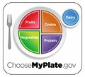
Orange Vegetables = 6 cups weekly Dry Beans & Peas = 2 cups weekly
Starchy Vegetables = 6 cups weekly
Other Vegetables = 5 cups weekly
Oils: Aim for 7 teaspoons of oil (unsafe:javascript: void(0);) a day.
Go Lean with Protein! Aim for this much every week:
Seafood = 10 oz weekly
Meat, Poultry & Eggs = 31 oz weekly
Nuts, Seeds & Soy Products = 5 oz weekly
* MyPlate contains recommendations only for calorie levels up to 3,200 per day. If Diet & Wellness Plus recommends more than 3,200 calories per day for you, talk to your instructor for guidance on how to use MyPlate.

Item Name |  | Meal |  | Quantity |  | Wt (g) Kcal
Banana |  | Breakfast |  | 1.00 item(s) |  | 118.00 |  | 105.02
Peanut Butter, Smooth |  | Breakfast |  | 3.00 tablespoon(s) |  | 48.00 |  | 287.04
TRADER JOES Salad, Kale Quinoa |  | Lunch |  | 2.50 cup(s) |  | 100.00 |  | 110.00
DORITOS COOL RANCH Tortilla Chips |  | Lunch |  | 2.00 ounce(s) |  | 56.70 |  | 300.00
TACO BELL Original Taco with Beef |  | Dinner |  | 4.00 item(s) |  | 312.00 |  | 714.48
Watermelon |  | Evening Snack |  | 1.75 cup(s) |  | 266.00 |  | 79.80
Water, Tap |  | Total Water |  | 50.00 fluid ounce(s) |  | 1,477.00 |  | 0.00
Total |  |  |  |  |  | 2,377.70 |  | 1,596.34
Item Name | Protein (g) | Carb (g) |  | Fat (g) |  | Sat Fat (g)
Banana | 1.29 |  | 26.95 |  | 0.39 |  | 0.13
Peanut Butter, Smooth | 10.66 |  | 10.71 |  | 24.65 |  | 4.96
TRADER JOES Salad, Kale Quinoa | 4.00 |  | 10.00 |  | 7.00 |  | 1.00
DORITOS COOL RANCH Tortilla Chips | 4.00 |  | 36.00 |  | 16.00 |  | 2.00
TACO BELL Original Taco with Beef | 27.64 |  | 61.93 |  | 39.62 |  | 13.68
Watermelon | 1.62 |  | 20.08 |  | 0.40 |  | 0.04
Water, Tap | 0.00 |  | 0.00 |  | 0.00 |  | 0.00
Total | 49.21 |  | 165.67 |  | 88.07 |  | 21.81
Item Name | Mono Fat (g) | Poly Fat (g) |  | Trans Fat (g) |  | Chol (mg)
Banana | 0.04 |  | 0.09 |  | 0.00 |  | 0.00
Peanut Butter, Smooth | 12.45 |  | 6.02 |  | 0.04 |  | 0.00
TRADER JOES Salad, Kale Quinoa | 0.00 |  | 0.00 |  | 0.00 |  | 0.00
DORITOS COOL RANCH Tortilla Chips | 0.00 |  | 0.00 |  | 0.00 |  | 0.00
TACO BELL Original Taco with Beef | 13.76 |  | 9.49 |  | 1.46 |  | 87.36
Watermelon | 0.10 |  | 0.13 |  | 0.00 |  | 0.00
Water, Tap | 0.00 |  | 0.00 |  | 0.00 |  | 0.00
Total | 26.35 |  | 15.73 |  | 1.49 |  | 87.36
Item Name | Linoleic (g) | Linolenic (g) |  | Diet Fiber (g) |  | Sugar (g)
Banana | 0.05 |  | 0.03 |  | 3.07 |  | 14.43
Peanut Butter, Smooth | 5.89 |  | 0.01 |  | 2.40 |  | 5.04
TRADER JOES Salad, Kale Quinoa | 0.00 |  | 0.00 |  | 3.00 |  | 4.00
DORITOS COOL RANCH Tortilla Chips | 0.00 |  | 0.00 |  | 4.00 |  | 1.00
TACO BELL Original Taco with Beef | 8.80 |  | 0.52 |  | 12.17 |  | 2.81
Watermelon | 0.13 |  | 0.00 |  | 1.06 |  | 16.49
Water, Tap | 0.00 |  | 0.00 |  | 0.00 |  | 0.00
Total | 14.87 |  | 0.57 |  | 25.70 |  | 43.77
Item Name | H2O (g) | Alcohol (g) |  | Thiamin (mg) |  | Ribo (mg)
Banana | 88.39 |  | 0.00 |  | 0.04 |  | 0.09
Peanut Butter, Smooth | 0.59 |  | 0.00 |  | 0.07 |  | 0.09
TRADER JOES Salad, Kale Quinoa | 0.00 |  | 0.00 |  | 0.00 |  | 0.00
DORITOS COOL RANCH Tortilla Chips | 0.00 |  | 0.00 |  | 0.12 |  | 0.07
TACO BELL Original Taco with Beef | 177.90 |  | 0.00 |  | 0.16 |  | 0.19
Watermelon | 243.26 |  | 0.00 |  | 0.09 |  | 0.06
Water, Tap | 1,475.53 |  | 0.00 |  | 0.00 |  | 0.00
Total | 1,985.67 |  | 0.00 |  | 0.47 |  | 0.49
Item Name | Niacin (mg) | Vit B6 (mg) |  | Vit B12 (µg) |  | Fol (DFE) (µg)
Item Name | Niacin (mg) |  | Vit B6 (mg) |  | Vit B12 (µg) |  | Fol (DFE) (µg)
Banana | 0.78 |  | 0.43 |  | 0.00 |  | 23.60
Peanut Butter, Smooth | 6.29 |  | 0.21 |  | 0.00 |  | 41.76
TRADER JOES Salad, Kale Quinoa | 0.00 |  | 0.00 |  | 0.00 |  | 0.00
DORITOS COOL RANCH Tortilla Chips | 0.00 |  | 0.16 |  | 0.00 |  | 0.00
TACO BELL Original Taco with Beef | 5.15 |  | 0.28 |  | 2.90 |  | 65.52
Watermelon | 0.47 |  | 0.12 |  | 0.00 |  | 7.98
Water, Tap | 0.00 |  | 0.00 |  | 0.00 |  | 0.00
Total | 12.70 |  | 1.21 |  | 2.90 |  | 138.86
Item Name | Vit C (mg) |  | Vit D (ug) (µg) |  | Vit A (RAE) (µg)  () |  | Vit A (IU) (IU)  ()
Banana | 10.27 |  | 0.00 |  | 3.54 |  | 75.52
Peanut Butter, Smooth | 0.00 |  | 0.00 |  | 0.00 |  | 0.00
TRADER JOES Salad, Kale Quinoa | 27.00 |  | 0.00 |  | 87.50 |  | 1,750.00
DORITOS COOL RANCH Tortilla Chips | 0.00 |  | 0.00 |  | 0.00 |  | 0.00
TACO BELL Original Taco with Beef | 1.25 |  | 0.00 |  | 12.48 |  | 240.24
Watermelon | 21.55 |  | 0.00 |  | 74.48 |  | 1,513.54
Water, Tap | 0.00 |  | 0.00 |  | 0.00 |  | 0.00
Total | 60.06 |  | 0.00 |  | 178.00 |  | 3,579.30
Item Name | Vit K (µg) |  | Alpha-T (mg)  () |  | Calcium (mg) |  | Iron (mg)
Banana | 0.59 |  | 0.12 |  | 5.90 |  | 0.31
Peanut Butter, Smooth | 0.14 |  | 4.37 |  | 23.52 |  | 0.84
TRADER JOES Salad, Kale Quinoa | 0.00 |  | 0.00 |  | 80.00 |  | 1.44
DORITOS COOL RANCH Tortilla Chips | 0.00 |  | 0.00 |  | 40.00 |  | 0.00
TACO BELL Original Taco with Beef | 47.74 |  | 1.87 |  | 277.68 |  | 3.71
Watermelon | 0.27 |  | 0.13 |  | 18.62 |  | 0.64
Water, Tap | 0.00 |  | 0.00 |  | 44.31 |  | 0.00
Total | 48.74 |  | 6.49 |  | 490.03 |  | 6.93
Item Name | Magn (mg) |  | Potas (mg) |  | Zinc (mg) |  | Sodium (mg)
Banana | 31.86 |  | 422.44 |  | 0.18 |  | 1.18
Peanut Butter, Smooth | 80.64 |  | 267.84 |  | 1.20 |  | 204.48
TRADER JOES Salad, Kale Quinoa | 0.00 |  | 0.00 |  | 0.00 |  | 180.00
DORITOS COOL RANCH Tortilla Chips | 32.00 |  | 0.00 |  | 0.00 |  | 360.00
TACO BELL Original Taco with Beef | 99.84 |  | 652.08 |  | 5.46 |  | 1,238.64
Watermelon | 26.60 |  | 297.92 |  | 0.27 |  | 2.66
Water, Tap | 14.77 |  | 14.77 |  | 0.00 |  | 44.31
Total | 285.71 |  | 1,655.05 |  | 7.11 |  | 2,031.27
5/5/2019
Item Name |  | Meal |  | Quantity |  | Wt (g) | Kcal
Total |  |  |  |  |  | 0.00 |  | 0.00
Item Name | Protein (g) |  | Carb (g) |  | Fat (g) |  | Sat Fat (g)
Total | 0.00 |  | 0.00 |  | 0.00 |  | 0.00
Item Name | Mono Fat (g) |  | Poly Fat (g) |  | Trans Fat (g) |  | Chol (mg)
Total | 0.00 |  | 0.00 |  | 0.00 |  | 0.00
Item Name | Linoleic (g) |  | Linolenic (g) |  | Diet Fiber (g) |  | Sugar (g)
Total | 0.00 |  | 0.00 |  | 0.00 |  | 0.00
Item Name | H2O (g) |  | Alcohol (g) |  | Thiamin (mg) |  | Ribo (mg)
Item Name | H2O (g) |  | Alcohol (g) |  | Thiamin (mg) |  | Ribo (mg)
Total | 0.00 |  | 0.00 |  | 0.00 |  | 0.00
Item Name | Niacin (mg) |  | Vit B6 (mg) |  | Vit B12 (µg) |  | Fol (DFE) (µg)
Total | 0.00 |  | 0.00 |  | 0.00 |  | 0.00
Item Name | Vit C (mg) |  | Vit D (ug) (µg) |  | Vit A (RAE) (µg)  () |  | Vit A (IU) (IU)  ()
Total | 0.00 |  | 0.00 |  | 0.00 |  | 0.00
Item Name | Vit K (µg) |  | Alpha-T (mg)  () |  | Calcium (mg) |  | Iron (mg)
Total | 0.00 |  | 0.00 |  | 0.00 |  | 0.00
Item Name | Magn (mg) |  | Potas (mg) |  | Zinc (mg) |  | Sodium (mg)
Total | 0.00 |  | 0.00 |  | 0.00 |  | 0.00

Energy Balance
5/3/2019, 5/5/2019, 5/5/2019
Date | kcal Consumed | kcal Burned Through Tracked  Activity | Number of  Hours of  Tracked  Activity | Number of  Hours with No Activity  Logged | kcal Burned at BMR Rate | Total kcal Burned | Net kcal
5/3/2019 | 1,596 | 0 | 0 | 24 | 1,844 | 1,844 | -248
5/5/2019 | 0 | 0 | 0 | 24 | 1,844 | 1,844 | -1,844
Total: | 1,596 | 0 | 0 | 48 | 3,688 | 3,688 | -2,092
Average: | 798 | 0 | 0 | 24 | 1,844 | 1,844 | -1,046

Appendix

• Height: _179_ [cm or m]
• Weight: _70_ (current in [kg])
• What is your "usual body weight": _72_ [kg]. When was the last time you were at this weight? ___03/2019___ [mm/yyyy] (Did you recently gain or lose any weight? In what time-frame? Do you know why?) gain weight because I changed my job now I'm sitting most of the time
• BMI: __23__
• Age: __29__
• Gender: __M__ [M/F]
o If female, are you pregnant? yes or no
• What is your activity level? _______sedentary____________ (sedentary, moderately active, or very active)
• Your own calculated Estimated Energy Requirement (EER) [Adult man = 662 - (9.53 * age) + PA * (15.91 * weight + 539.6 * height);; Adult woman: EER = 354 - (6.91 * age) + PA * (9.36 * weight + 726 * height)]: ________ kcal/day [PA is your physical activity factor, which may be 1.1 or 1.2 or 1.3 depending on your activity level]
• Your own calculated estimated fluid need [body weight in kg * 35 - 40 ] : _________ ml/day
• Dietary supplement intake: ____________________________________ If you don't take any, please indicate "N/A".
• Optional:
o Are there any (medical) conditions you would be willing to share with me, which might affect your nutrition intake and daily activities? ___________________________________ If you are not aware of anything, please indicate "N/A".
o Are there any medical conditions in your family that you would be willing to share with me, which might affect your nutrition intake and daily activities? _______________________________ If you are not aware of anything, please indicate "N/A".
o Are you taking any medications on a daily basis that you would be willing to share with me, which might affect your nutrition intake and daily activities? ______________________________________ If you don't take any, please indicate"N/A".

